LEVERAGING SOCIAL MEDIA ACCESSABILITY FOR ALL: CURRICULUM

Story of Change: Ria 4
Story of Change: Nirmal 4
Making Every Conversation Accessible 6
Different Needs Call For Different Solutions 6
Become Agents of Change 7
Why It’s Important 8
About This Campaign 9
Curriculum Objectives 9
How to use the curriculum 10
Understanding key concepts 10
People with Disabilities 10
Accessible 10
Accessible Communication 10
Making pictures accessible 10
Colour contrast 10
Audio description 10
Closed captions 11
Subtitles 11
Transcripts 11
Assistive Technologies 11
Section 1 – Basic Tips for Posting Content 12
Hashtags 12
Use simple language 12
Emoji 12
Colour 13
Animated Gifs 13
Section 2 - Improving the Accessibility of Photos 14
Alt Text 14
Tips for writing great alt text descriptions 15
How to edit alt text on Facebook 15
To see and edit alt text for a photo before you post it on Facebook: 15
To change the alt text of a photo after you’ve posted it: 16
How to edit alt text on Instagram 16
To see and edit alt text for a photo before you post it on Instagram: 16
To change the alt text of a photo after you've already posted it on Instagram: 17
Did you know? 17
Section 3 – Improving the accessibility of videos 17
Captions and Transcripts 18
Captioning Tools on Facebook 18
How to manage captions on Facebook 18
To add captions to your Page's video: 18
How to enable auto-generated captions in Facebook Live 19
How to manually add captions in Facebook Live 19
Auto-generated captions on Instagram 19
To enable auto-generated captions before sharing a video post on Instagram: 20
To manage captions for a video post you already shared: 20
Auto-generated captions for Instagram Stories and Reels 21
Audio Description 21
Audio Transcripts 22

Story of Change: Ria

Ria is in her first year of college. She is a person with blindness and started using her smartphone for reading and writing independently in her school. Using technology has always meant independence to her. From travelling by metro and using her SmartCane to navigate to going to the park with her friends, she enjoys the freedom it offers. She is excited about this new phase of her life and what all it has to offer. She is studying literature and hopes to write a novel one day. She is part of a Facebook Book Review Club where she posts articles on the latest books she’s read regularly. Besides reading and writing, one of her favourite hobbies is to watch new films and documentaries on Netflix. She uses Audio-described format and often watches it along with her younger sister.

Story of Change: Nirmal

Nirmal is in her late 60s and is based in Bengaluru. She wasn’t sure how life would be with her daughter moving to Delhi last November, but she has come to enjoy her time. She has joined a small club in her locality for computer classes and she is enjoying learning again. It seemed a bit difficult at first but through hits and misses she’s learning it’s not rocket science. She has WhatsApp and likes to get on a video call with her daughter. They even occasionally eat their meals together virtually. She is a bit nervous about her trip in March to Delhi because she’ll be flying alone but she is also excited to see her daughter. Her favourite singer is Geeta Dutt and Nirmal often plays her songs on a Gaana app, humming along as she goes about her day.
Can you think of any such stories from your life?

What role has social media or technology played in your stories?

Making Every Conversation Accessible

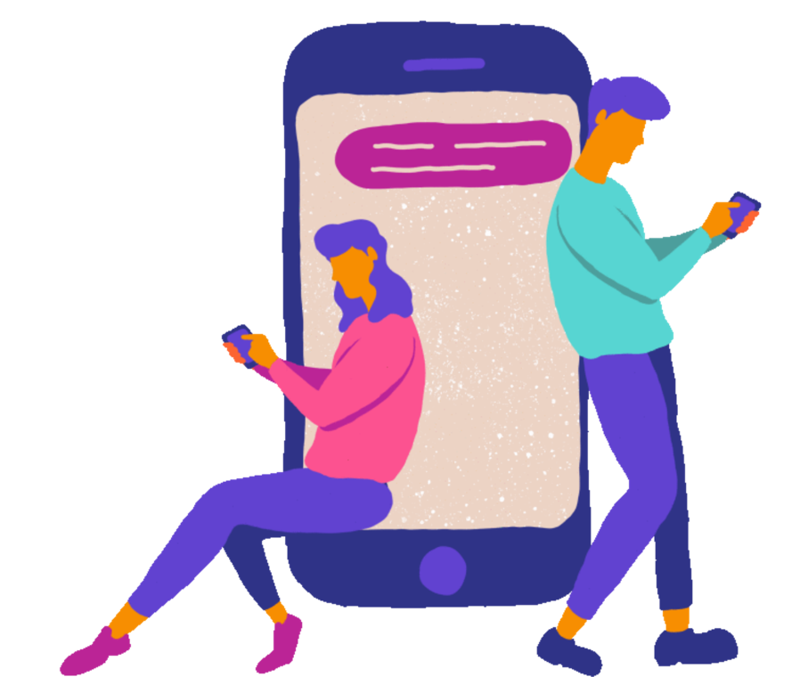

Communication is a big part of our lives and one of the most important human rights. We all communicate every day – with our teachers, peers, governments, our families, even with our furry friends!

Social media has taken our communication even further, it has transformed the way you and I exchange information, discuss our ideas and has become such an intrinsic part of our lives that we don’t even notice it anymore. Can you recall the last time you said a big “Hello” to your grandmother on a WhatsApp call? Or you laughed out loud because your best friend sent you a funny cat video? Our guess it was not that long ago.

It is of great importance that social media and information and communication is available to everyone so that we can all enjoy what it has to offer and utilize its potential. Unfortunately, many studies show that some groups who may have diverse needs do not get to enjoy social media or the communication it offers on an equal basis with others.

Different Needs Call For Different Solutions

People with blindness who can’t see often use their technology to read out what’s written on their screen. But did you know unless you describe what the photo is about, the technology may not read anything out. Similarly, our grandparents may not be able to read texts properly because the text may be too small for them but a mobile phone can easily enlarge the text as much as they like, making the joke you shared with them easily readable.

These small changes and guidelines are what we call accessibility and can make the difference between someone receiving information and feeling included and someone feeling left out. Not sure if you understand what to do or don’t know how to start making your communication accessible? We have you covered. Through this curriculum you can learn what these steps can do, how you can make sure the information and communication you share is accessible, and what you can do if you need any more tips or require more information.

Whether you are a person with disability, a government agency wanting to share news far and wide, an influencer wanting to make sure your content is enjoyable for all, or a young person communicating with your college friends, you’ll find all the information you need in this curriculum.

Become Agents of Change

Once you go through this curriculum, you will:
- Understand what assistive technology is and how digital accessibility can transform your simple text into information which can be read, heard, or seen by all
- Know how to make your posts and content accessible for all
- Learn how to ensure your photos and videos are enjoyable to all, including for people who cannot see or hear and who may use assistive devices for communication
- Have a ready list of resources you can refer to for all your needs and know where to reach out for more support.

Are you ready to become agents of change? We are excited to be on this journey with you and can’t wait to get started! Explore the tips and guidelines in this curriculum to see how you can play your part in making sure every conversation remains accessible and join us as we make social media a more inclusive and accessible space for all.

Why It’s Important

Before we dive into this curriculum, let’s explore why it is so crucial that we communicate the accessible way on social media?

- Most businesses, governments, news channels, and people now have Facebook, WhatsApp, and Instagram accounts where they share many of their products and news. We wouldn’t want anyone to miss out on these opportunities, news, and information.

- Today, social media isn’t just a space where you talk to your friends. From getting to know about upcoming scholarships, to sharing e-books and chapters, to even learning about tough mathematics concepts through YouTube, its where learning happens. Did you know a study conducted last year with participants with disabilities found that 80% of participants used social media for their education and training? Social media as a learning tool opens tremendous opportunities for all, but it can do that if we make sure our content is accessible.

- During the last few years we all saw how Covid disrupted our lives as we couldn’t step out or meet our friends. Social media continued to ensure that we all could talk to our loved ones and communicate. It allowed us all to remain connected. This connection is important but it must be open to all, won’t you agree?
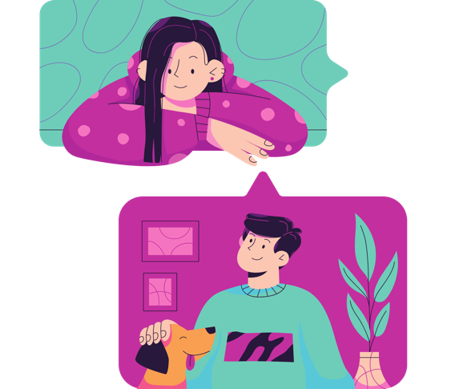

- Social Media impacts everyone, including content access for millions and billons of people in India and across the world. No, we aren’t exaggerating. Facebook has 2.91 billion monthly active users; YouTube has 2.56 billion monthly active users; WhatsApp has 2 billion monthly active users; and Instagram has 1.48 billion monthly active users! What’s more? India has 467 million active social media users and the world’s largest audiences on all these platforms - Facebook, YouTube, WhatsApp, and Instagram!

- The Government of India and International laws also protect every individual’s access to information, including that of India’s 26 million+ persons with disabilities.

About This Campaign

You see even though digital accessibility and the simple steps that help make content accessible seem small they can go a long way in ensuring big impact. Sadly, even though technology is there and many steps and features exist that help us to send and receive information in an accessible way, many of us aren’t aware how to use these steps. But we can start to learn today.

It is for this very reason that Saksham Trust with support of Meta has designed this curriculum as part of its campaign “Leveraging Social Media AccessAbility For All”. The campaign aims to build an inclusive and accessible digital world where everyone is able to meaningfully exchange information, content, and share their ideas on an equal footing.

Curriculum Objectives

The curriculum will:

- Generate awareness on accessibility and build skills of persons with disabilities and their organisations and communities to create and receive content in a form that they like
- Generate awareness and build capacities of all stakeholders - United Nations Agencies, Government Agencies, Academic Institutions and think tanks, IT and corporate professionals, media, influencers, and young adults – to ensure the content they create and receive remains inclusive and accessible.
- Create easy-to-follow audio-visual-text learning resources and provide examples for anyone and everyone who may wish to learn how to create content and spread their message loud and clear so it reaches millions of people!

The tips and guidelines in this curriculum have been borrowed from Meta’s ‘Creating Accessible Content’ best practices guide, Instagram Accessibility Help Centre, and Facebook Accessibility Help Center. We thank Meta for their guidance and advice during the development of the curriculum.

How to use the curriculum

You can read the different sections independently from each other or together, in a way that best suits you. Each section provides you step-by-step guidance on how to create accessible content. It includes clear objectives, guidelines on how to make content accessible, as well as suggestions on relevant resources and next steps.

Understanding key concepts

Before we learn how to create accessible content, let’s get to know a few key terms and concepts which we will come across in our learning.

People with Disabilities
People with disabilities have a long term condition. People with disabilities often face barriers which mean they are not able to join in with everyday life. Persons with disabilities are not one homogenous group but different. Their needs can be different too.

Accessible
Accessible means it is easy to use and suitable for people with different needs. We might have to share our content in a few different ways to make sure they reach the right people. For example, if we communicate by radio and microphones, it’s not good for deaf people.

Accessible Communication
There are rules about making information or content online accessible. These simple rules are important. They mean that our information can be read by lots of different people.

Making pictures accessible
We can make pictures accessible to people who have difficulty seeing by adding some alt text. Alt text is some words to describe the picture. The words are hidden, but can be read out to people using a text reading device.

Colour contrast
Choosing colours that are very different from each other so they stand out.

Audio description
Audio description is where someone speaks about what is happening on the video, film or show.
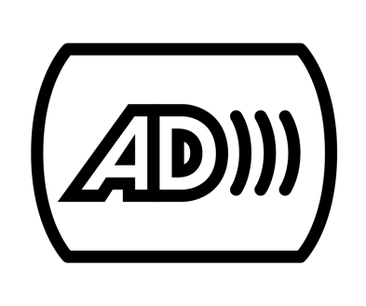

Closed captions
This is a text version of the sounds and words being spoken on the film or video.

Subtitles
These are on videos. They describe the spoken words on the film or video. They are also useful for people who don’t understand the language being used.

Transcripts
This is where someone writes down what people have said and prints it out for people to read after the meeting.

Assistive Technologies
Assistive technologies are any item, piece of equipment, or product that is used to increase, maintain, or improve the functional capabilities of persons with disabilities.

Assistive technologies for ICTs include:
- Screen readers
- Refreshable Braille displays
- Magnification software
- Voice recognition and dictation software
- Head pointers and other alternative pointing devices
- Switch devices

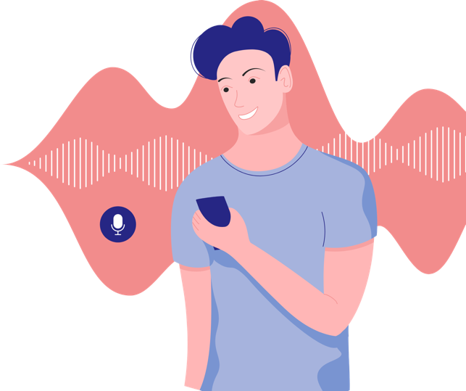

Section 1 – Basic Tips for Posting Content

Welcome to Section 1 of the curriculum! In this section you will learn some basic tips for posting content. While many of the tips we give you are for creating accessible content on Facebook and Instagram, you can also use these tips more broadly. By the end of this module you will learn how to use simple language in your communication, the case to use for writing hashtags, the correct way to use emojis, colour contrast, and GIFs!

Hashtags

- Capitalize the first letter of each word when you use hashtags.
- For example, use #BestFriendForever instead of #bestfriendforever.
- This is called CamelCase - it’s easier to read and enables screen readers used by people who are blind and visually impaired, to pronounce hashtags properly.

Use simple language

- Whenever possible, use simple language and shorter sentences.

- Longer sentences can be harder to follow and understand.

- Use sentence case instead of all capital letters to make it easier for people with cognitive and learning disabilities to read.

Emoji
- Avoid creating emoticons using text like : - )

- These are hard for many people to read or understand, and screen readers for the blind have difficulty describing their meaning.

- Instead use emojis, the small pictures used to convey emotions and ideas – like the smiley face example shown here. 😀
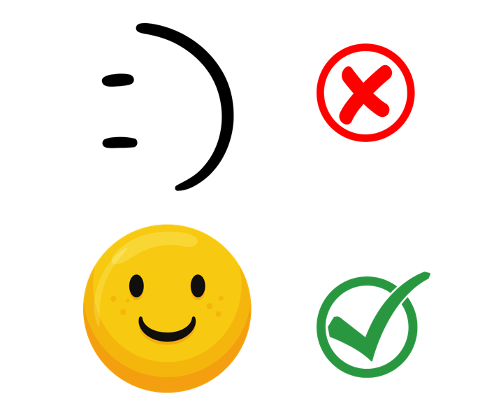
- Each emoji already has a matching text description that is spoken by screen readers for the blind.

Colour

- Use colours that provide a contrast ratio of at least 3:1 against the background--particularly for text. If the text is smaller than 18pt, then use 4.5:1 ratio, or higher.
- High contrast has a greater impact on making text easier to read than text size.
- Colour text is harder to read when it appears on top of photographs and complex images.
- So place text over a solid, high-contrast background and increase the contrast between the text and its background.

Animated Gifs

- Strong visual patterns including strobing, flickering, blinking, and flashing can make it extremely difficult or even impossible for people with cognitive or learning disabilities to focus and read your post.
- These visuals can even cause seizures for some people.
- To avoid this, make sure your GIFs flash no more than three times per second and run for less than 5 seconds.

Section 2 - Improving the Accessibility of Photos

In section 2 you will learn how to make your photos accessible. By the end of this module you will learn what alt text is, how to write great alt text descriptions, and how to edit alt text on Facebook and Instagram both before and after you post it.

Alt Text

- Photos are made accessible to persons who are blind or low vision through the use of brief text descriptions called “alternative text” or “Alt Text” that can be read aloud by a screen reader.

- Meta has deployed AI-driven automatic photo-description technology that describes objects in photos to people with vision loss – called automatic alt text or “AAT”.

- AAT uses object recognition to generate a description of photos to enable people using screen readers to hear a list of items that photos may contain.

- More than 80% of images displayed on Facebook and Instagram now contain AAT.

- Even though Facebook and Instagram offer automatic photo-description technology, called automatic alt text or “AAT”, when uploading a photo, take the time to include a concise alt-text description to provide a better description of the photo.

Tips for writing great alt text descriptions:

- Write alt text as if you’re describing the image to someone.
- For example, “walking through the park with my new puppy.”
- Be descriptive and provide context about meaning, content, and/or function.
- Keep the description to 125 characters or less.
- Include punctuation, but avoid formatting such as bold, italics, etc.
- Call out graphs, charts, screenshots, collages, logos, or anything else that’s not included in a basic photo.
- For text in images, start off with the statement “With text that reads…” followed by the verbatim text in quotes.

How to edit alt text on Facebook

You can edit alt text for a photo before and after you post it.

To see and edit alt text for a photo before you post it on Facebook:

- Click Photo/Video at the top of your News Feed.
- Select the photo you want to add.
- Hover over the photo and click to the pencil icon to edit.
- The automatically generated text will be shown on the left side of your photo. Click Override generated alt text to edit it.
- Write your alt text in the box. To change back to the automatically generated text, click Clear.
- To save your alt text, click Save in the bottom left.

To change the alt text of a photo after you’ve posted it:

- Click the photo to open it.
- Click the icon with three horizontal dots in the top right and select Change Alt Text.
- Click Override generated alt text or change the alt text in the text box. You can also click Clear to change your edited alt text back to the automatically generated text.
- Click Save.

How to edit alt text on Instagram

To see and edit alt text for a photo before you post it on Instagram:

- Start by taking a photo or uploading an existing photo to Instagram.
- Choose a filter and edit the image, then tap Next on iPhone or the right-facing arrow icon on Android devices.
- Tap Advanced Settings at the bottom of the screen.
- Tap Write Alt Text.
- Write your alt text in the box and tap Done on iPhone or the checkmark icon on Android devices.

To change the alt text of a photo after you've already posted it on Instagram:

- Go to the photo and tap the icon with three horizontal dots on iPhone or the icon with three vertical dots on Android devices .

- Tap Edit Alt Text in the bottom right.

- Write the alt text in the box and tap Done on iPhone or the checkmark icon on Android devices.

Did you know?

- You can also add an image description to the caption for each photo that you post so that a screen reader can describe the photo.

- This is separate from an alt text description.

- When adding a description to the post accompanying a photo, be descriptive – but the shorter the description is, the better.

Section 3 – Improving the accessibility of videos

In this last section you will learn how to make your videos accessible. By the end of this module you will learn what captions and transcripts are, what we mean by audio-description, how to manage captions on Facebook and Instagram, what we mean by auto-generated captions and how to enable it, and how to manually add captions, both before and after you post videos!

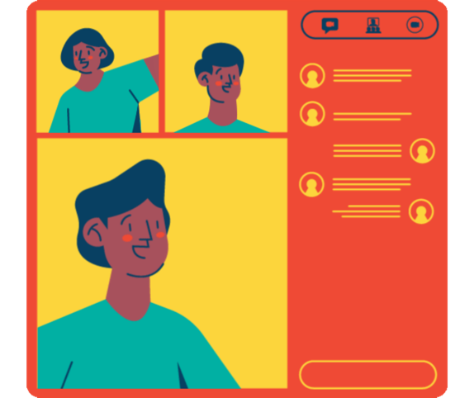

Captions and Transcripts

- Include captions or a transcript with your videos.

- Without them, your video may exclude people who are deaf or hard of hearing.

- They’re also useful for people who are watching your videos in a noisy environment, quiet spaces, or when they may not have headphones.

- Transcripts are easy to create.

- They’re just a plain text version of what’s being spoken in the audio recording.

- It’s also helpful to include descriptions of sound effects and other noises, and mention who is speaking.

Captioning Tools on Facebook

- On Facebook, you can automatically generate captions and edit them, write them yourself, or you can upload a SubRip (.srt) file.

- Auto-generated captions are available for Facebook ads and Pages and Facebook Live.

- In addition to enabling auto-generated captions on Facebook Live, you can choose to manually add captions, either by using a third-party closed caption tool or by working with a vendor to add real-time closed captions.

How to manage captions on Facebook

To add captions to your Page's video:

- From your News Feed, click the flag icon next to Pages in the left menu.
- Go to your Page.
- Click Photo/Video at the top of your Page's timeline, then select a video from your computer.
- After your video has uploaded, click Subtitles & Captions (CC) in the column on the right.
- Once your video has finished uploading, select whether you'd like to auto-generate captions, write them yourself or upload a SubRip (.srt) file.
- Click Next, then click Publish.
- If you choose to upload a SubRip (.srt) file, make sure that your caption files are correctly named and formatted before you upload them.

How to enable auto-generated captions in Facebook Live

As we mentioned earlier, Facebook also enables its Live streamers to enable auto-generated captions or manually add captions, either by using a third-party closed caption inserter tool or by working with a vendor to add real-time closed captions into their FB Live broadcasts.

To turn on auto-generated captions for a Facebook Live broadcast:

- Click Live Video at the top of your News Feed.

- Click Create Live Video.

- Click Settings, then click Viewer.
Tap the icon with three horizontal dots next to Turn on auto-generated captions. Captions will be automatically generated during your live video

How to manually add captions in Facebook Live

To manually add caption to a Facebook Live broadcast:

- Before going live, set up a third-party tool or start working with a third-party caption provider to enable live captions for your broadcast.
- Along with the video footage you capture in your live broadcast, insert or pass-through embedded CEA-608 captions data into the live encoder.
- Stream your live broadcast feed via the Facebook Live API.
- People can then view the embedded closed captions for your broadcast in Facebook

Auto-generated captions on Instagram

To enable auto-generated captions before sharing a video post on Instagram:

- Tap the “plus” icon at the top.

- To upload a video from your phone’s library, select the video you’d like to share.

- To record a video, tap the camera icon above your phone’s library. Tap and hold the white circle at the bottom to start recording and lift your finger to stop.

- Tap Next in the top right to edit your video.

- Select a filter at the bottom. Swipe left on the filters to see more.

- Tap Trim at the bottom and use the sliders to change the start and end points of your video.

- After editing your video, tap Next in the top right.

- Tap Advanced Settings.

- Scroll to Accessibility and tap the slider icon next to Auto-generate captions to turn on captions for your video.

To manage captions for a video post you already shared:

- Tap the icon with three horizontal dots on iPhone or the icon with three vertical dots on Android devices at the top of the video.

- Tap Manage Captions.

From here you can:
- 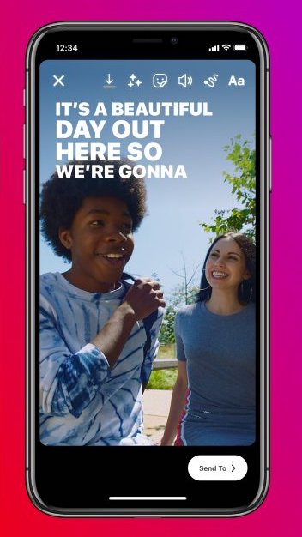Tap the slider icon next to Captions to turn them on or off.

- Tap the slider icon next to Remove Captions for Everyone. This will make captions for your video unavailable.

- If captions are available on video posts you share, they’ll automatically show unless you turn them off.

Auto-generated captions for Instagram Stories and Reels

- Use the Captions Sticker on IG Stories and Reels to automatically transcribe video audio.

- When creating a video, go to the sticker tray, select Captions, and rewatch your video to make sure the captions are correct.

- Edit the text, color, size, and placement to maximize accessibility.

- If you see an error in the captions, select the word (or words) you want to change and edit the text.

- Remember to maximize the color contrast.

Audio Description

Before we begin, let’s understand a little more about audio-description. Audio description is where someone speaks about what is happening on the video, film, or show. These descriptions are inserted into the audio track during moments when there is no dialogue, and they provide context to a person who is blind or has low vision.

- Audio descriptions can be written and recorded with voice actors, or a vendor can create audio descriptions using synthesized (or human) voices in post-production.

- You can include a link to a separate audio-described version when it’s inappropriate to deliver audio descriptions to everyone.

- There is a universal logo for audio description – “A” and “D” letters next to one another with three sound bars to the right of the “D” – which can help sighted audiences recognize the audio-described version and understand why they are hearing descriptions.

- Use this AD logo as a watermark in one of the lower corners of the audio-described video.

- If time or cost, do not allow for audio descriptions then add a written description of the visual components of the video to the accompanying post copy so that a screen reader can describe the video to people who are blind or have low vision.

- Video descriptions should include enough information to communicate the main visual takeaways and key parts of the video.

Audio Transcripts

- Include a text transcript with audio recordings.

- In addition to people with hearing loss, transcripts are useful to people who are watching your video in a noisy environment or when they need to keep quiet and may not have headphones handy.

- A good transcript includes time codes, references who is speaking, and provides descriptions of sound effects and other informative noises.

- If a transcript is long (for recordings 30 minutes or more) consider providing a topic index with time codes at the top of the transcript so people can jump to the part that interests them and have a better understanding of what the audio contains.

